

Internal Memorandum

**To:** CIO

**CC:** Room Judge

**From:** Team B

**Date:** 10/21/2018

**Memo #:** 1

**Re:** Lost System Info

Good Afternoon,

Here is the requested system information for our five machines.

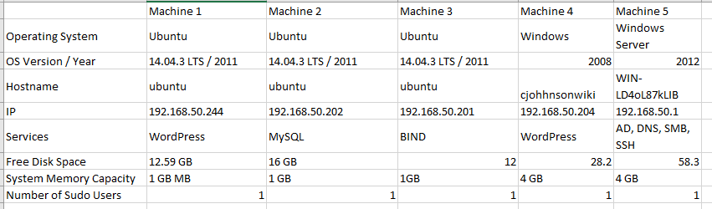

James Simmons

Team B

*In accordance with HAL Memorandum policy, the entire header must be completed or the recipient may not acknowledge this as an official memorandum. Professional communications methods and decorum must be observed at all times.*